College of Engineering, Pune

**Software Engineering Mini Project - II**

**(Project Report)**

T.Y Computer Engineering 2021-22

Div: 1 Batch: T4

**Group Members**

Rajkumar Sawant (111903066)

Sanjyot Gaidhani (111903084)

**Faculty Advisor**

Mrs. T. R. Pattanshetti

# **Problem Statement: -**

To build the platform where any organization can perform **Real time** **Violence Detection** from CCTV or IP cameras without any human interaction.

# **Objectives: -**

1. To provide platform for monitoring live footage
2. To provide security encryption by running system only inside organization
3. To trigger alarm whenever any violence is happening
4. To direct notify to Police & Administrative authorities in severe cases

# **Motivation: -**

As per the reports we can see there are several violence cases reported every day. But I could be tracked at the initial stage only with our project.

It is highly inconvenient to check all the CCTV footage continuously to keep watch on violence. With our project we aim to automate this task effectively and efficiently. So, to reduce manpower required and make the system more accurate.

Security officials, police can use this to East check any violence cases happening in CCTV prone areas. get easy notification and service to send notification to higher authorities as well.

In this era of technology, we aim to help in automating the security sector which plays a significant role in our daily life.

# **Summary of SRS: -**

**Purpose:** Our system **Real Time violence detection in CCTV camera** gives better results in violence detection in multiple footages than the individual keep watch on them. If effectively reduces the manpower requirement and efficiently providing with accurate results.

**Product Perspective:** The main aim of this system is to effectively detect and report any violence cases happening in area under connected CCTV network

**Product functions:**

1. Instant notification if violence detected: If in a continuous evaluating frames violence value exceeds threshold (predefined value) then it instantly notifies the user by alarm.

2. Classification into Severe and non-severe instance: If provides add functionality to check the violence level in a continuous footage provided by CCTC into severe and non-severe.

* In case of severe violence detection, it directly sends notification to higher authorities.
* In case of non-severe violence detection, it provides rights to the user to send the notification to higher authorities or not.

**Software Quality Attributes:**

1. Planned approach towards working.
2. Maintainability.
3. Reliability.
4. No Redundancy.
5. Usability.
6. Easy to Operate

**UML & Explanation: -**

**1) Usecase Diagram**:

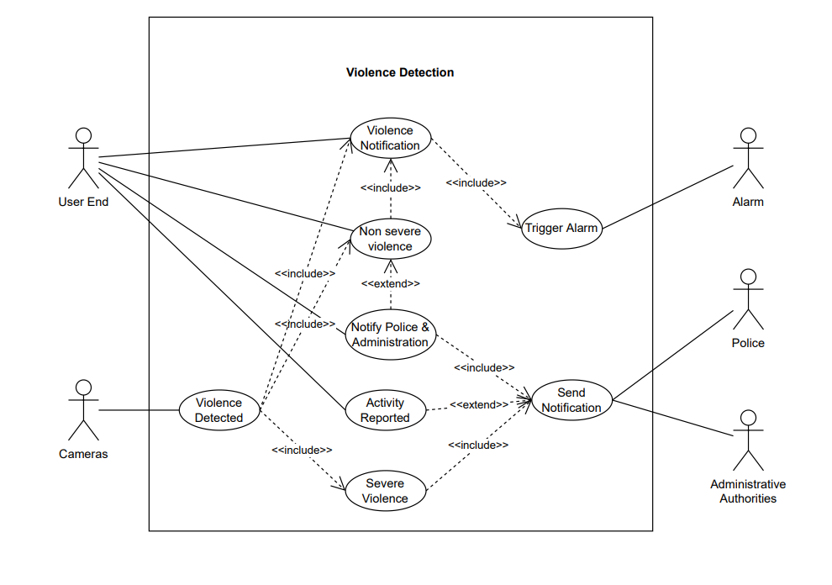

It is used to represent dynamic behavior of System. It encapsulates the system’s functionality by incorporating use cases, actors & their relationship.

Purpose of Use case is:

1. Depicts external view of system
2. Gather the system needs

**2) Class Diagram:**

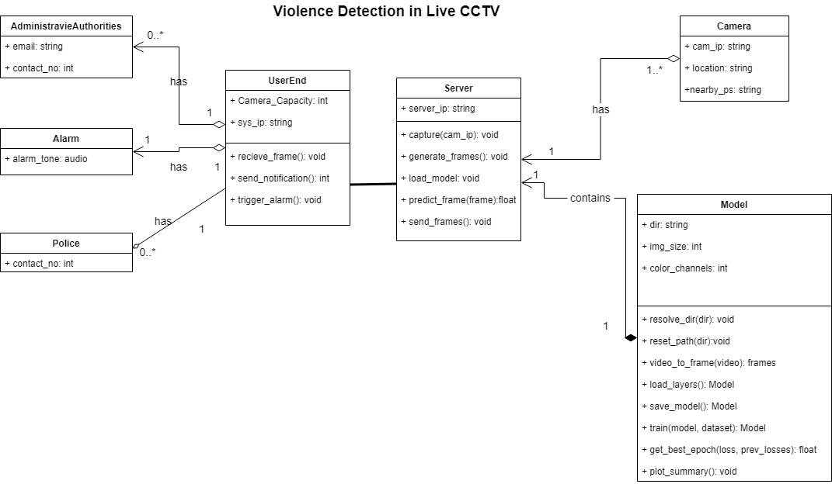

The class diagram depicts a static view of an application. A class consist of its objects and may inherit from other classes.

Purpose of Class diagram:

1. Analyses and designs static view of an application.

2. Describes a major responsibility of system.

**3) Swimlane Diagram:**

It is also a graphical representation of the System. Swimlanes are sometimes called functional bands. It simply describes who is responsible for the activities being performed in the activity diagram and how they are responsible. The activity diagram only represents the activities being performed, but Swimlane describes who does what in a process or activity performed.

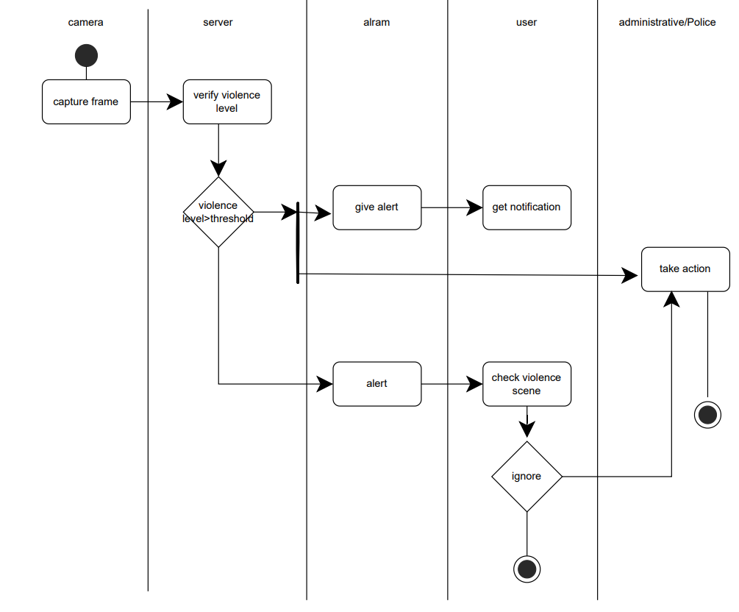

**4) Sequence Diagram:**

The sequence diagram represents the flow of messages in the system.

Purpose of Sequence diagram:

1. To model high level interaction among active objects within a system.

2. To model interaction among objects inside a collaboration realizing the use case.

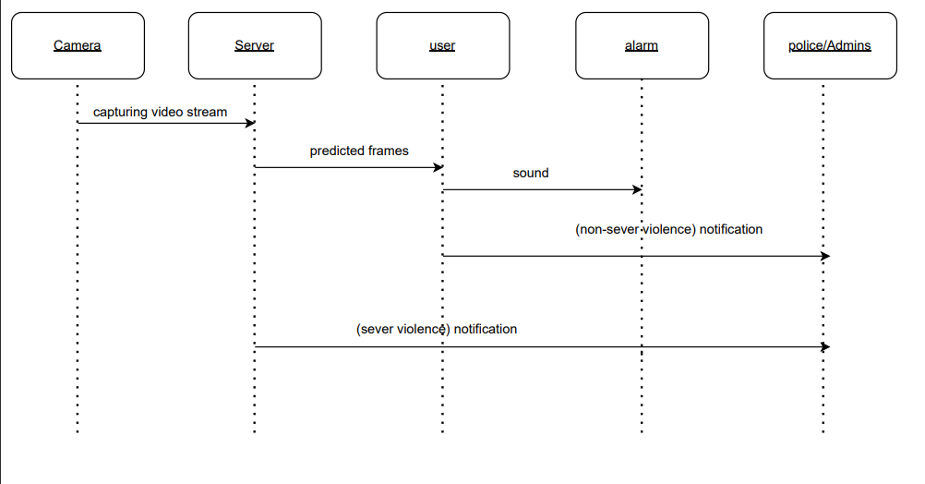

**5) Component Diagram:**

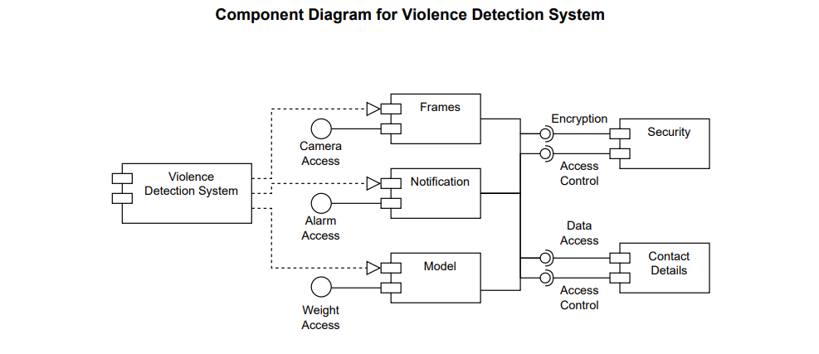

The component diagram is used to break down a large object-oriented system into the smaller components. It models the physical view of system.

Purpose of Component diagram:

1. It envisions each component of system.

2. It depicts the relationship and organization of components

**6) State Diagram:**

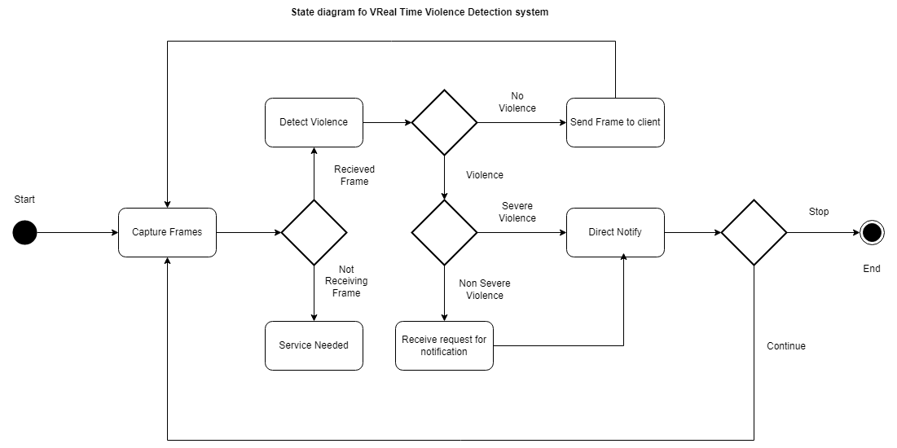

A state diagram is used to represent the condition of the system or part of the system at finite instances of time. It captures the software system's behavior. It models the behavior of a class, a subsystem, a package, and a complete system.

**Implementation**: -

1. Graphical user interface

   Description automatically generatedModel Training dataset download & import
2. 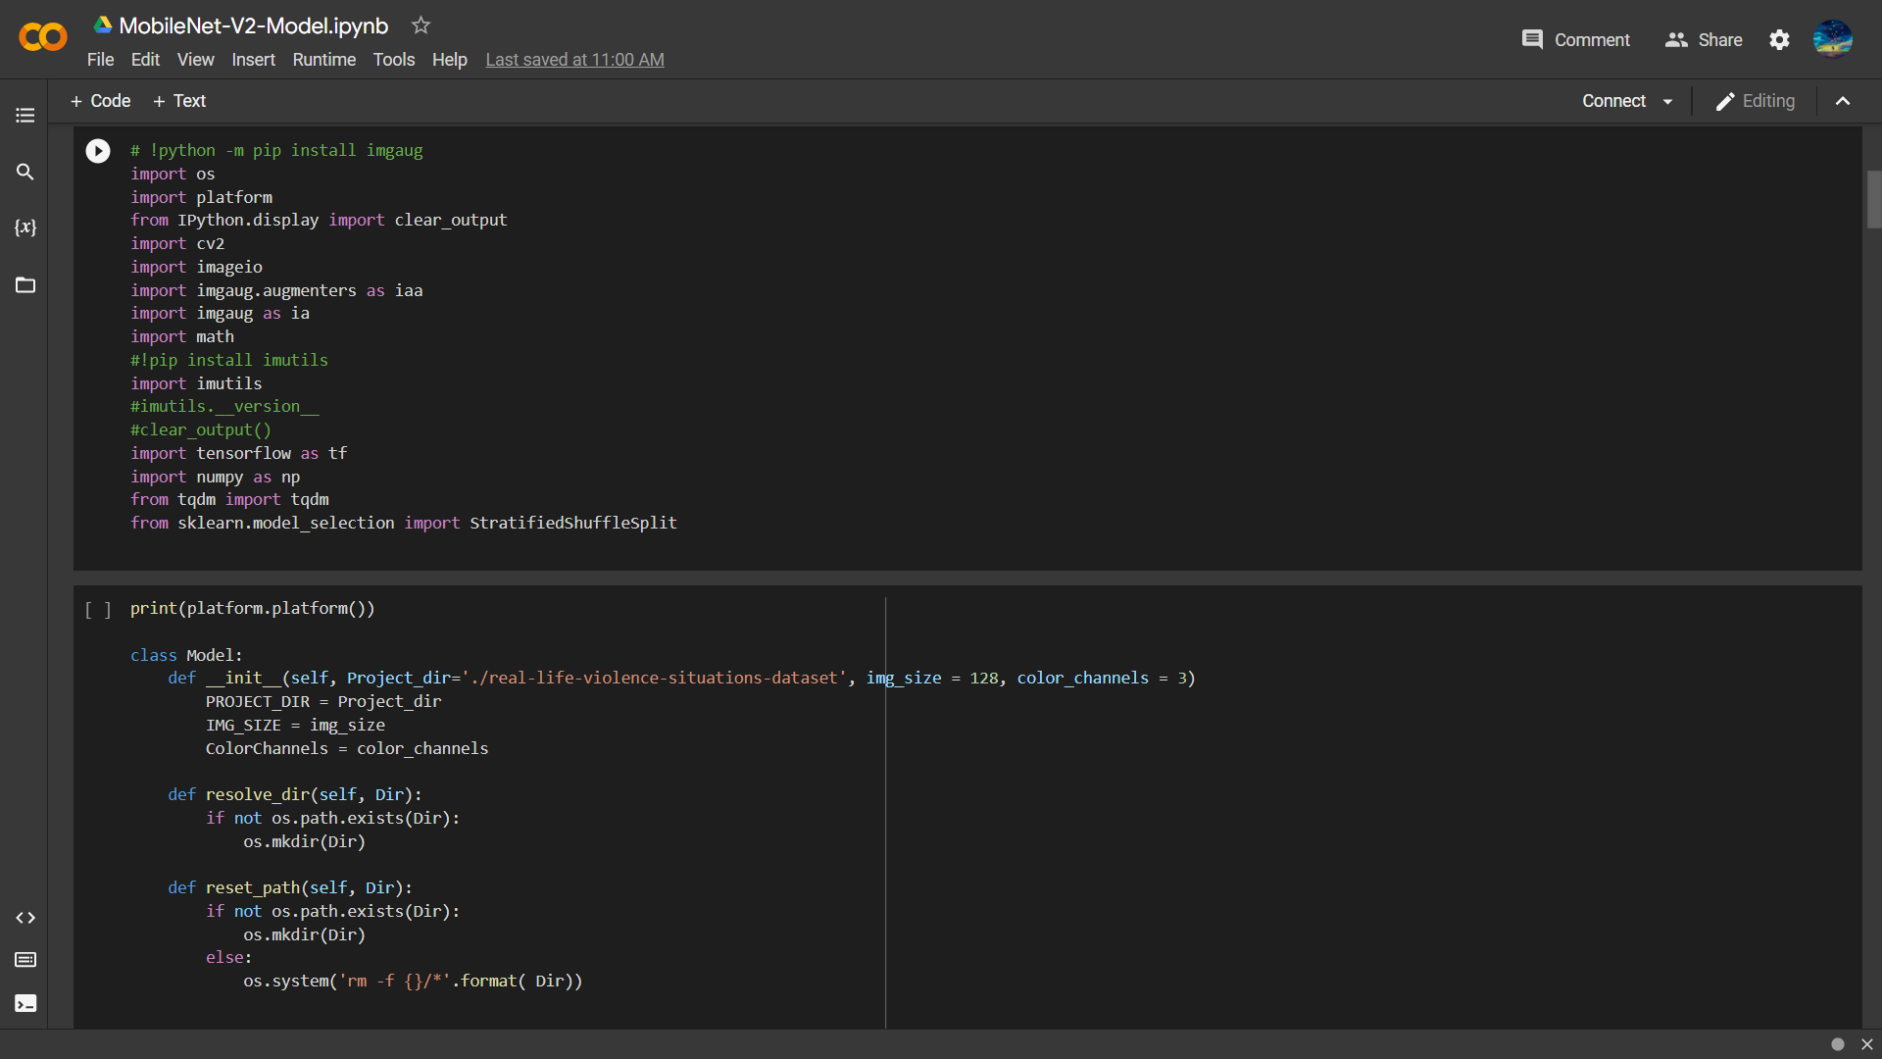Importing necessary libraries
3. 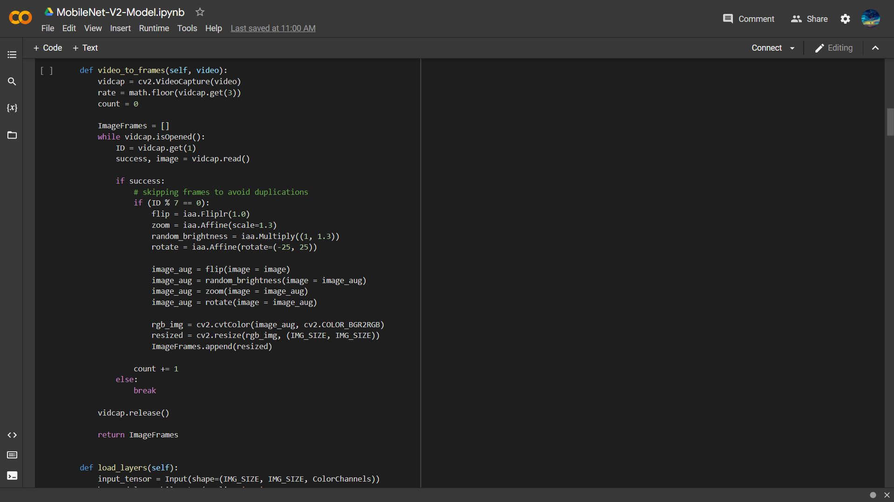Model Design

1. Graphical user interface, text

   Description automatically generated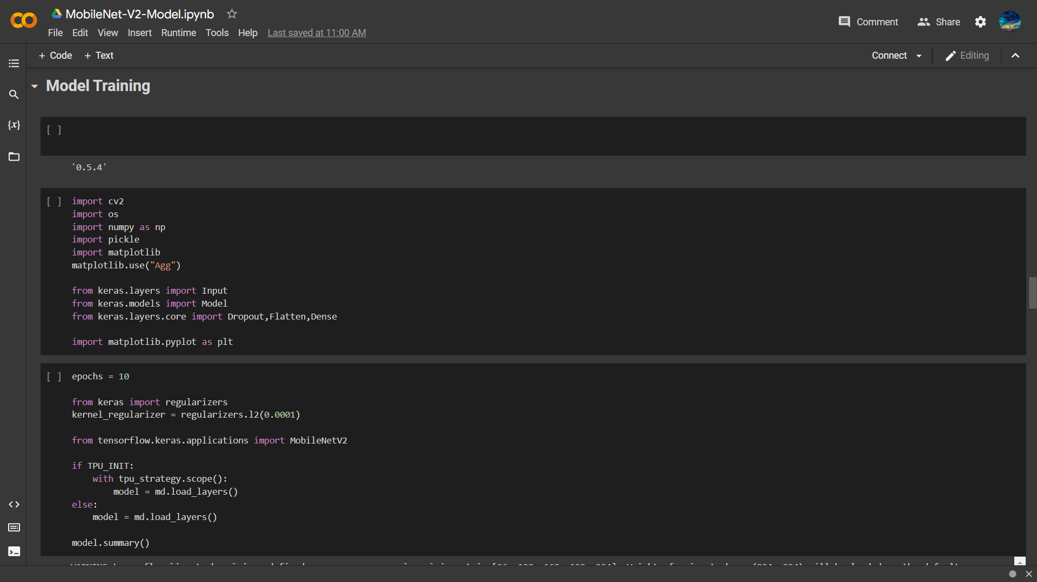Model Training
2. 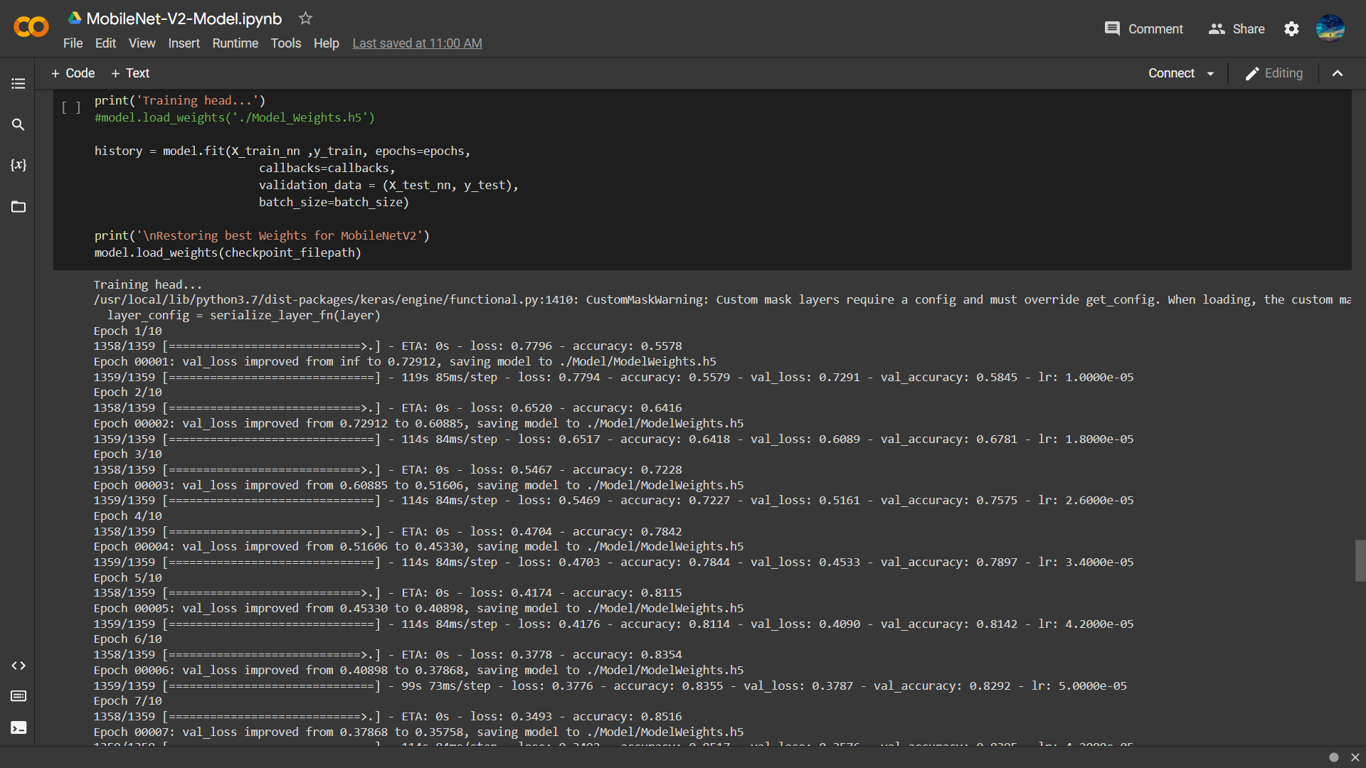Text

   Description automatically generatedTraining Output
3. Text

   Description automatically generatedA screenshot of a computer

   Description automatically generatedPrinting Training Summary

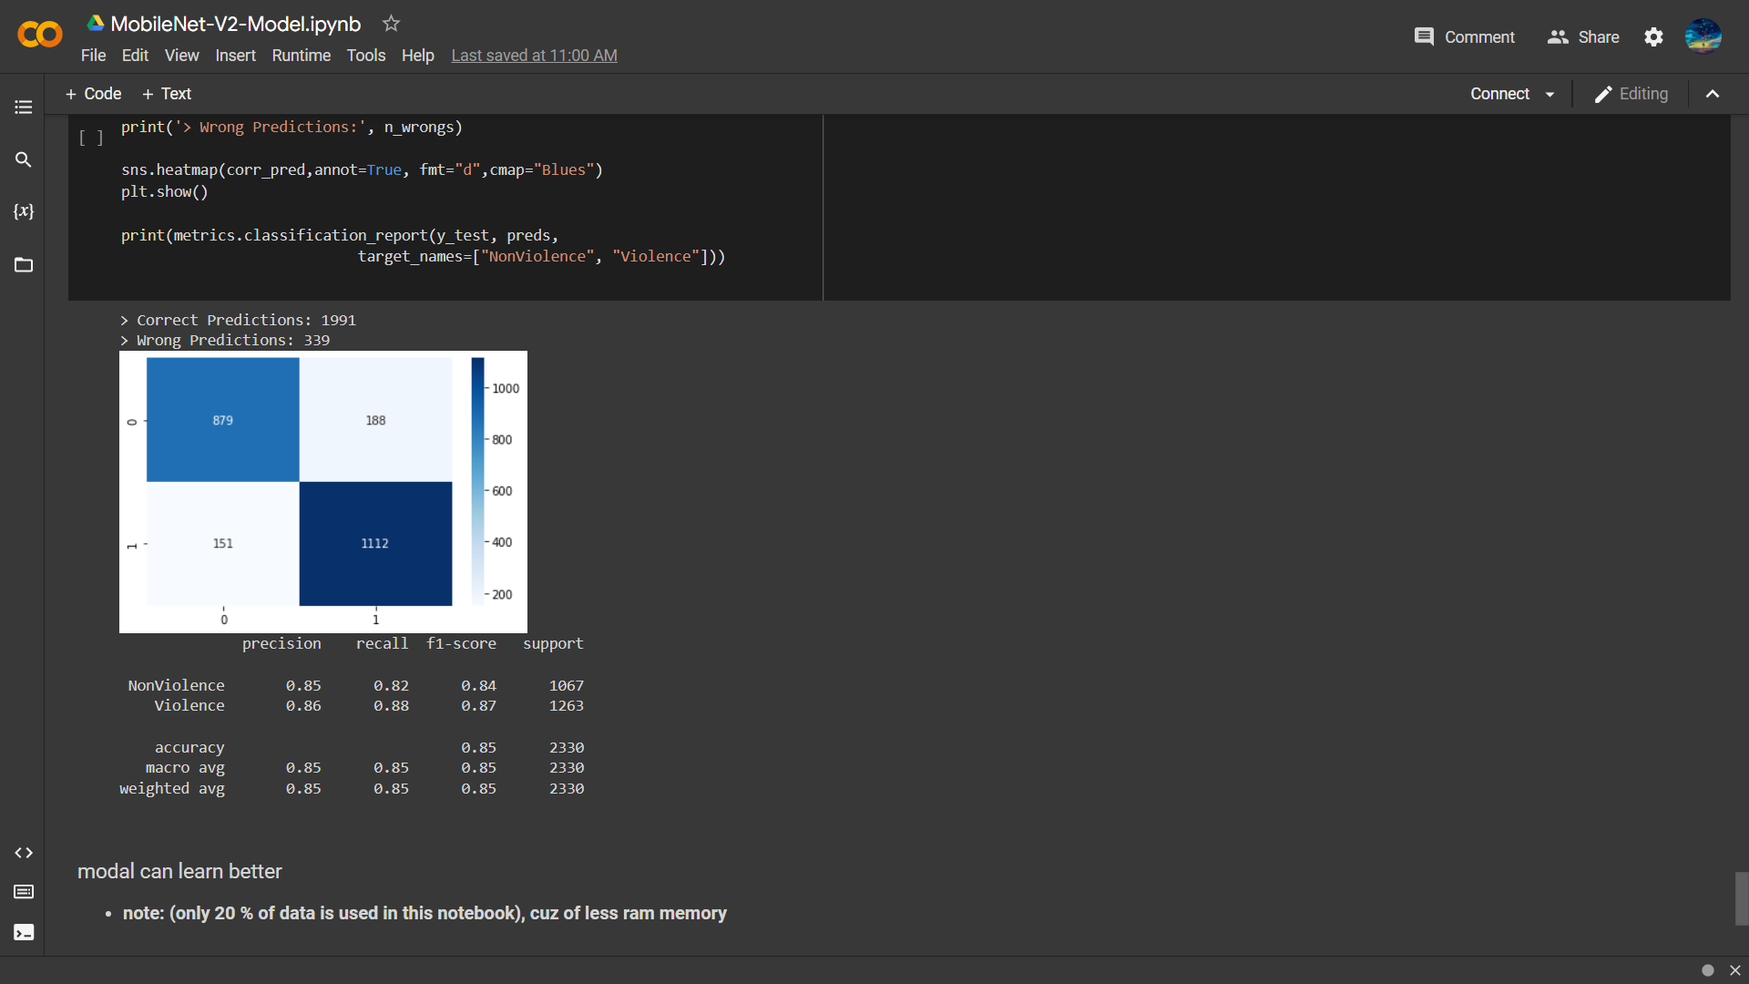

1. Server Implementation

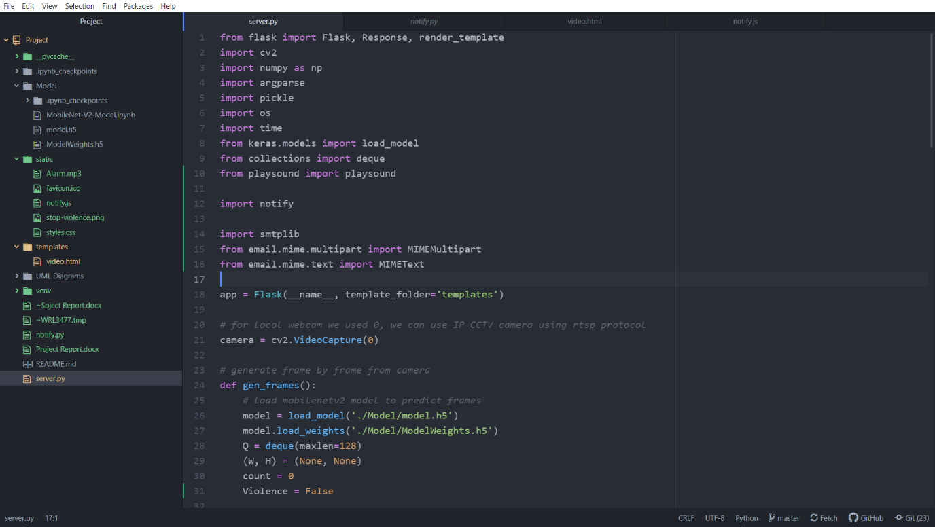

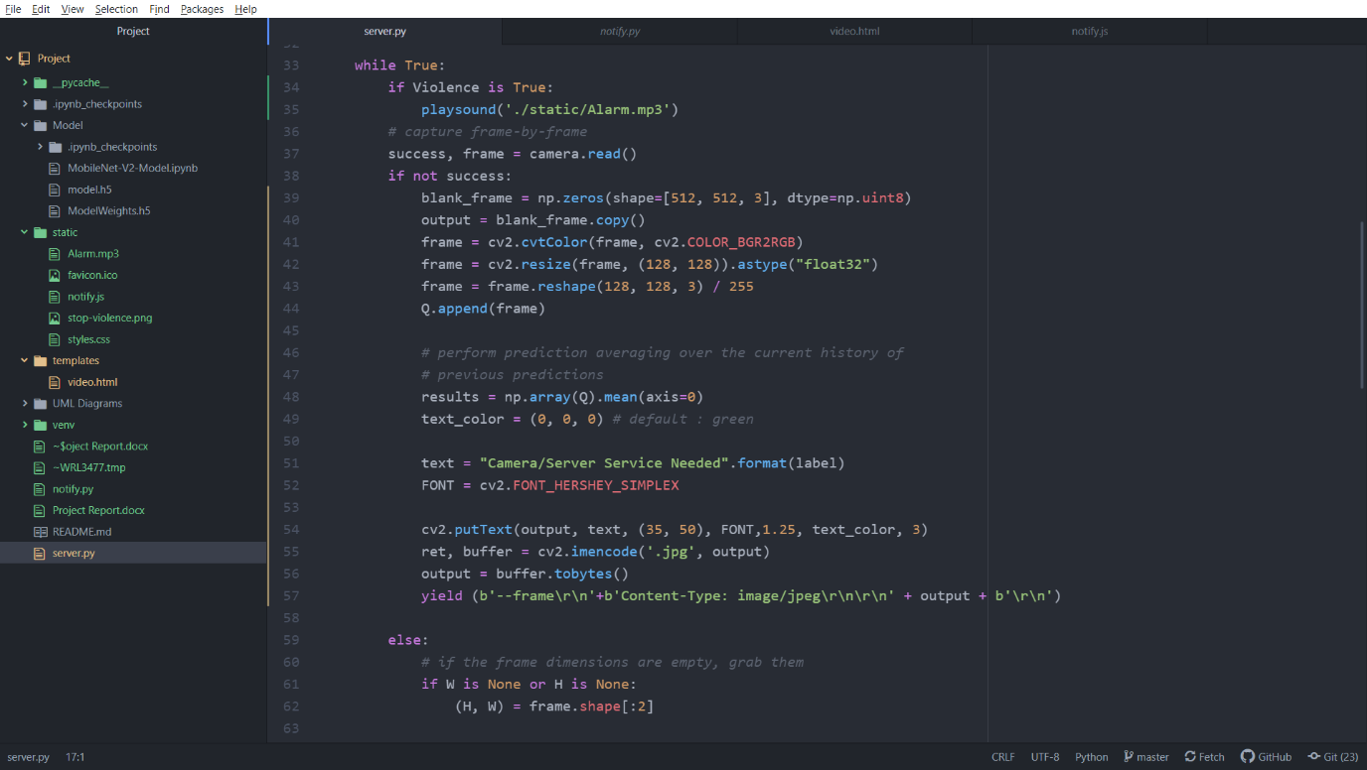

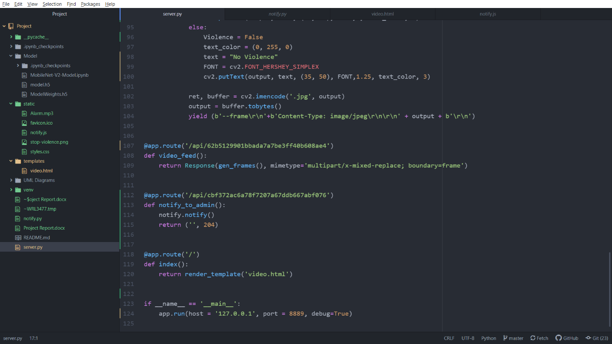

1. Dashboard

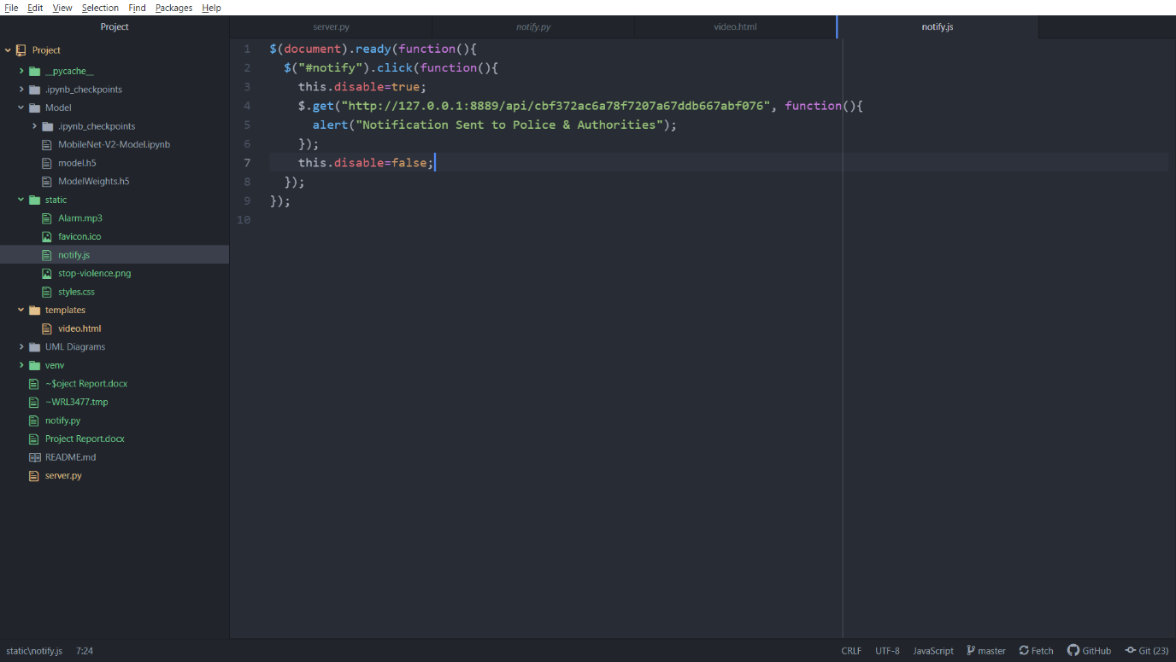

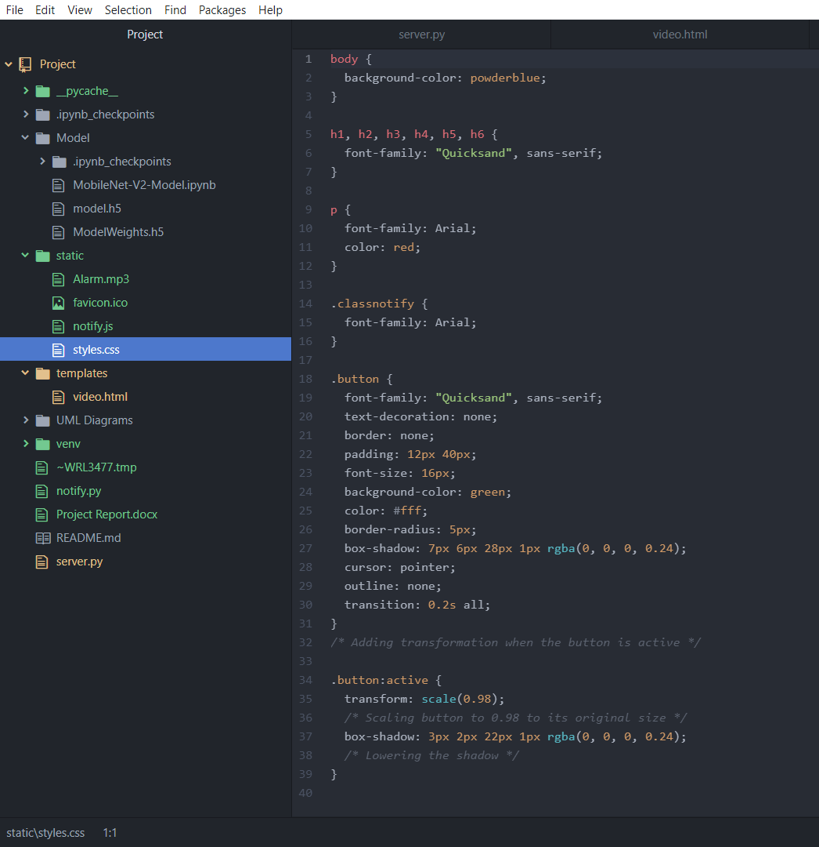

1. Notification

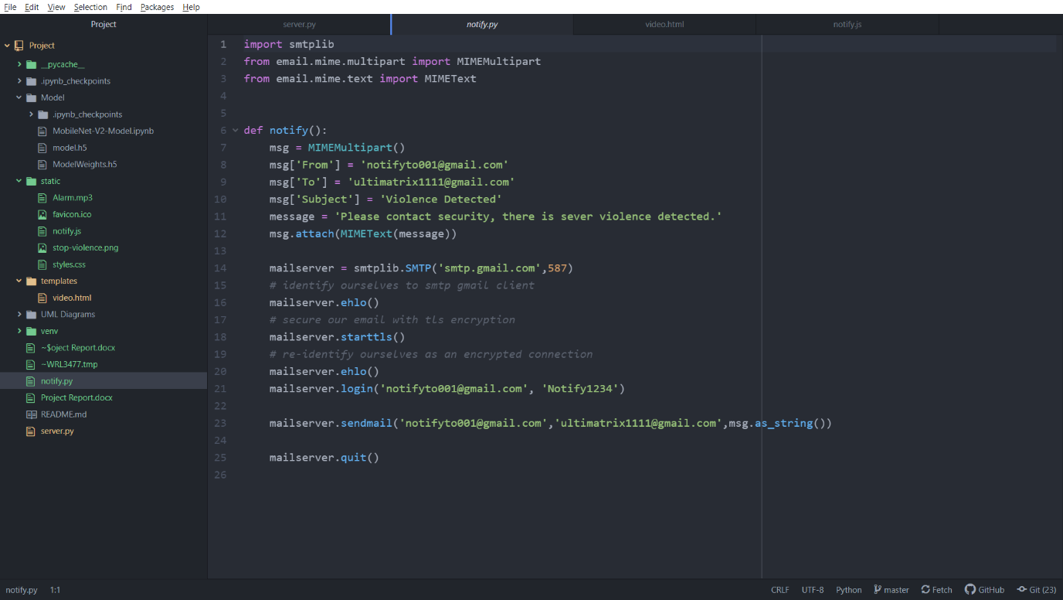

**Results: -**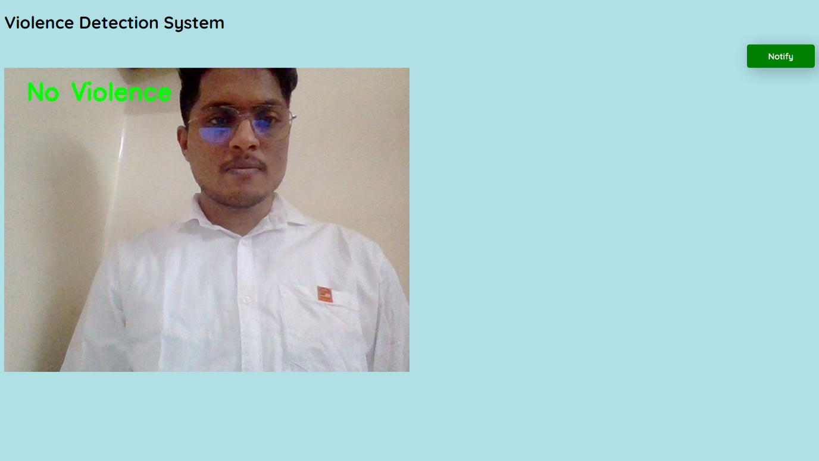

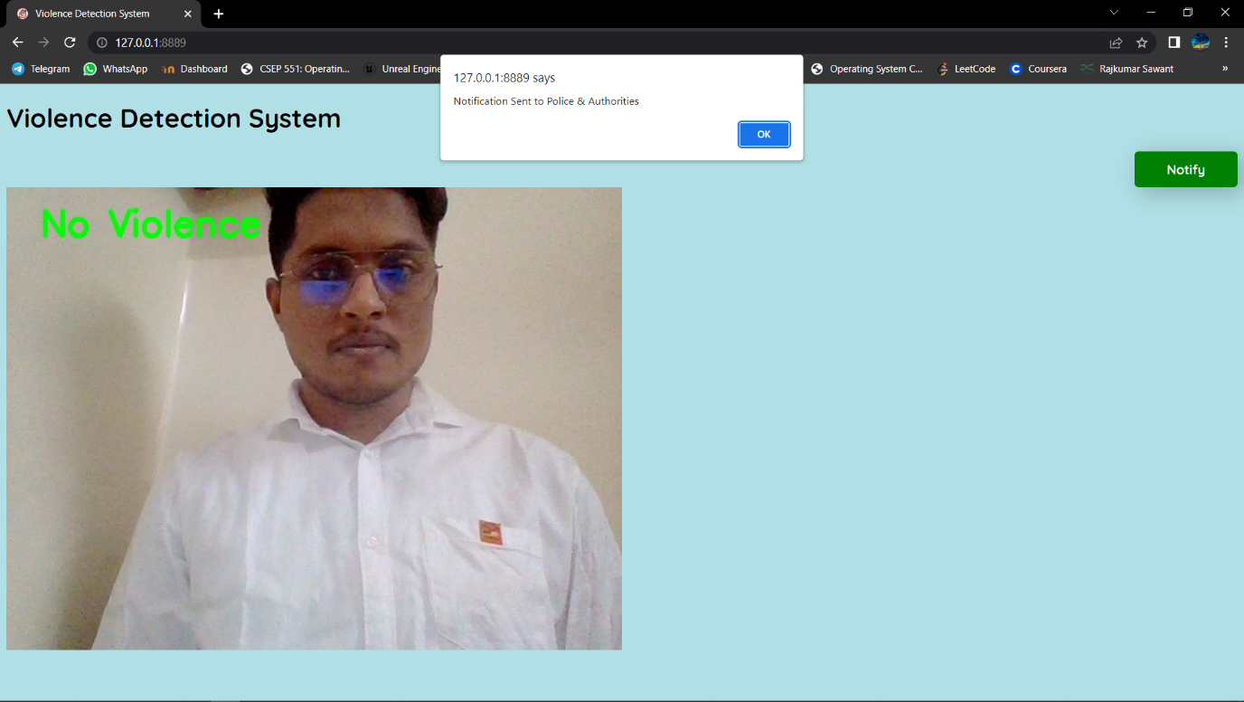

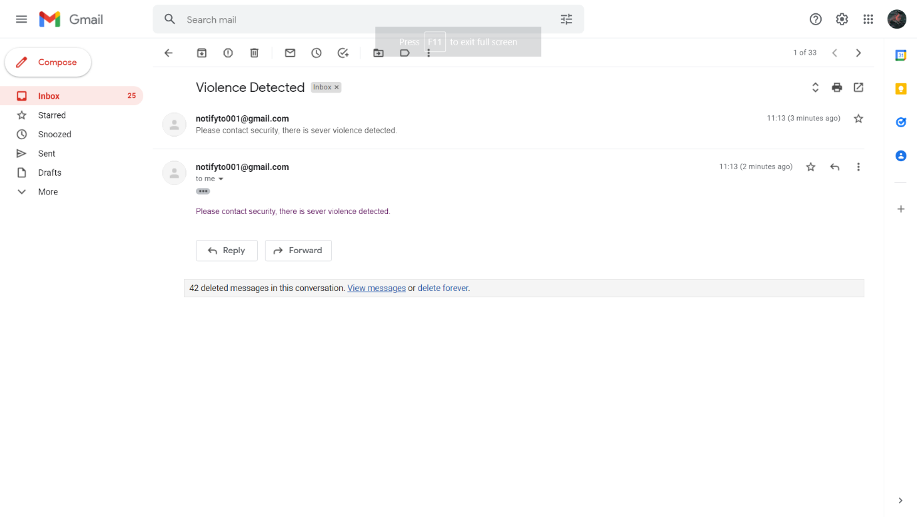

# **Testing**

**Performance Testing** –

System can receive continuous stream of captured frames as 30 frames per seconds. For higher rate we need to improve system hardware capacity.

We had tested platform for only single camera, due to lack of hardware support.

**Security Testing** –

Security is non-functional software testing technique used to determine if information & data in a system is protected. The main goal of this is to find loopholes & vulnerabilities present in system.

We have used automated testing **HCL AppScan** & **AppScan Go** software to perform SAST test on our platform for detecting vulnerabilities in early development lifecycle.

For predicted frames, we are using base64 encryption method to increase security. As our platform support for local network of organization, it provides additional security.

**Integration Testing –**

Our platform support only for latest versions of **MS EDGE, Google Chrome & Firefox** browsers.

# **Conclusion**

To conclude, this is a simple real time violence detection system which enables automated detection & notification. On the user side dashboard, they can immediately act if some unwanted things happen in the coverage area of camera.

# **Future Scope**

* This system is helpful for big government organizations & companies having large areas for surveillance
* We will add reinforcement learning techniques to our model for getting better accuracy over time
* We will integrate this platform with existing CCTV surveillance systems between cameras & captured data collection system

# **GitHub Project Repository: -**

# [**https://github.com/codeplusmath/Real-Time-Violence-Detection-from-CCTV.git**](https://github.com/codeplusmath/Real-Time-Violence-Detection-from-CCTV.git)